Task 5.3: (Syllabus Task 10) Build a Student CRUD application using Spring Boot to Perform Create, Read, Update, and Delete operations using a relational database in postman tool.
STEP 1: Create Spring Boot Project
Project Details:
- Project: Maven
- Language: Java
- Group: com.example
- Artifact: studentapp
- Packaging: Jar
- Java: 17 (or your version)
Dependencies:
Spring Web
Spring Data JPA
MySQL Driver
Project Structure Image:
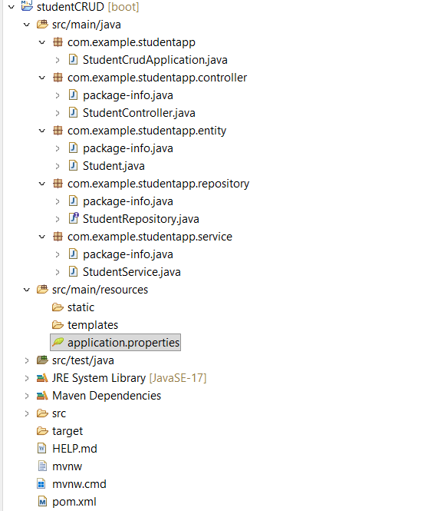
Pom.xml
<?xml version="1.0" encoding="UTF-8"?>
<project xmlns="http://maven.apache.org/POM/4.0.0" xmlns:xsi="http://www.w3.org/2001/XMLSchema-instance"
xsi:schemaLocation="http://maven.apache.org/POM/4.0.0 https://maven.apache.org/xsd/maven-4.0.0.xsd">
<modelVersion>4.0.0</modelVersion>
<parent>
<groupId>org.springframework.boot</groupId>
<artifactId>spring-boot-starter-parent</artifactId>
<version>4.0.3</version>
<relativePath/> <!-- lookup parent from repository -->
</parent>
<groupId>com.example</groupId>
<artifactId>studentapp</artifactId>
<version>0.0.1-SNAPSHOT</version>
<name>studentCRUD</name>
<description>Demo project for Spring Boot</description>
<url/>
<licenses>
<license/>
</licenses>
<developers>
<developer/>
</developers>
<scm>
<connection/>
<developerConnection/>
<tag/>
<url/>
</scm>
<properties>
<java.version>17</java.version>
</properties>
<dependencies>
<dependency>
<groupId>org.springframework.boot</groupId>
<artifactId>spring-boot-starter-data-jpa</artifactId>
</dependency>
<dependency>
<groupId>org.springframework.boot</groupId>
<artifactId>spring-boot-starter-webmvc</artifactId>
</dependency>
<dependency>
<groupId>com.mysql</groupId>
<artifactId>mysql-connector-j</artifactId>
<scope>runtime</scope>
</dependency>
<dependency>
<groupId>org.springframework.boot</groupId>
<artifactId>spring-boot-starter-data-jpa-test</artifactId>
<scope>test</scope>
</dependency>
<dependency>
<groupId>org.springframework.boot</groupId>
<artifactId>spring-boot-starter-webmvc-test</artifactId>
<scope>test</scope>
</dependency>
</dependencies>
<build>
<plugins>
<plugin>
<groupId>org.springframework.boot</groupId>
<artifactId>spring-boot-maven-plugin</artifactId>
</plugin>
</plugins>
</build
</project>
STEP 2: Configure Database (application.properties)
spring.application.name=studentCRUD
spring.datasource.url=jdbc:mysql://localhost:3306/studentdb
spring.datasource.username=root
spring.datasource.password=computer
spring.jpa.hibernate.ddl-auto=update
spring.jpa.show-sql=true
Create database in MySQL:
create database studentdb;
STEP 3: Create Student Entity
package: com.example.studentapp.entity
class:Student
package com.example.studentapp.entity;

import jakarta.persistence.*;
@Entity
@Table(name = "students")
public class Student {
@Id
@GeneratedValue(strategy = GenerationType.IDENTITY)
private Long id;
private String name;
private String email;
private String course;
// Constructors
public Student() {}
public Student(String name, String email, String course) {
this.name = name;
this.email = email;
this.course = course;
}
// Getters and Setters
public Long getId() { return id; }
public void setId(Long id) { this.id = id; }
public String getName() { return name; }
public void setName(String name) { this.name = name; }
public String getEmail() { return email; }
public void setEmail(String email) { this.email = email; }

public String getCourse() { return course; }
public void setCourse(String course) { this.course = course; }
}
STEP 4: Create Repository
package: repository
class:StudentRepository
package com.example.studentapp.repository;
import org.springframework.data.jpa.repository.JpaRepository;
import com.example.studentapp.entity.Student;
public interface StudentRepository extends JpaRepository<Student, Long> {
}
STEP 5: Create Service Layer
package: service
class:StudentService
package com.example.studentapp.service
import java.util.List;
import org.springframework.beans.factory.annotation.Autowired;
import org.springframework.stereotype.Service;
import com.example.studentapp.entity.Student;
import com.example.studentapp.repository.StudentRepository;
@Service
public class StudentService
@Autowired
private StudentRepository repository;

public Student saveStudent(Student student) {
return repository.save(student);
}
public List<Student> getAllStudents() {
return repository.findAll();
}
public Student getStudentById(Long id) {
return repository.findById(id).orElse(null);
}
public Student updateStudent(Long id, Student student) {
Student existing = repository.findById(id).orElse(null);
if (existing != null) {
existing.setName(student.getName());
existing.setEmail(student.getEmail());
existing.setCourse(student.getCourse());
return repository.save(existing);
}
return null;
}
public String deleteStudent(Long id) {
repository.deleteById(id);
return "Student deleted successfully!";
}
}

STEP 6: Create Controller
package: controller
class:StudentController
package com.example.studentapp.controller;
import java.util.List;
import org.springframework.beans.factory.annotation.Autowired;
import org.springframework.web.bind.annotation.*;
import com.example.studentapp.entity.Student;
import com.example.studentapp.service.StudentService;
@RestController
@RequestMapping("/students")
public class StudentController {
@Autowired
private StudentService service;
// CREATE
@PostMapping
public Student createStudent(@RequestBody Student student) {
return service.saveStudent(student);
}
// READ ALL
@GetMapping
public List<Student> getAllStudents() {
return service.getAllStudents();
}

// READ BY ID
@GetMapping("/{id}")
public Student getStudentById(@PathVariable Long id) {
return service.getStudentById(id);
}
// UPDATE
@PutMapping("/{id}")
public Student updateStudent(@PathVariable Long id, @RequestBody Student student) {
return service.updateStudent(id, student);
}
// DELETE
@DeleteMapping("/{id}")
public String deleteStudent(@PathVariable Long id) {
return service.deleteStudent(id);
}
}

STEP 7: Run the Application
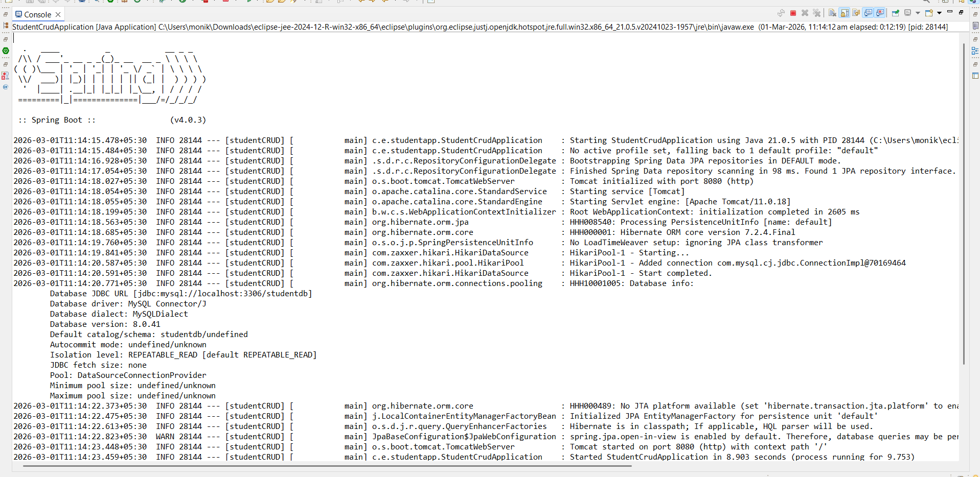
STEP 8: Test in Postman
CREATE Student
POST
http://localhost:8080/students
Body → Raw → JSON
{
"name": "Mounika",
"email": "mounika@gmail.com",
"course": "Spring Boot"
}
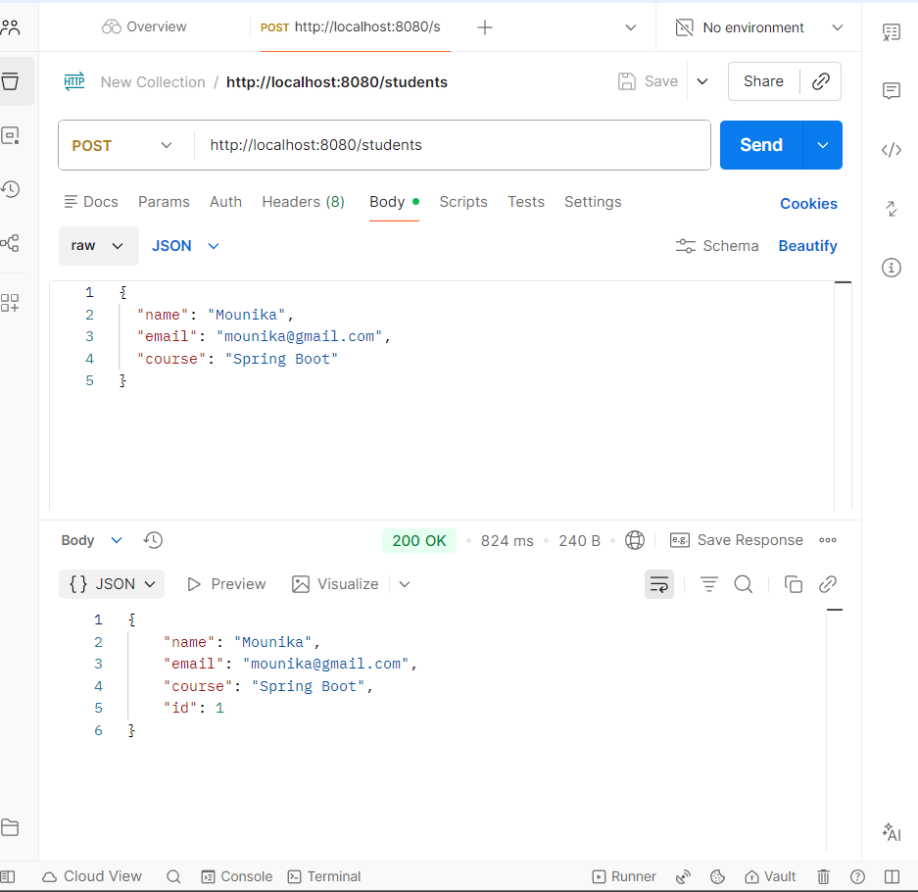
GET All Students
GET
http://localhost:8080/students

GET By ID
GET
http://localhost:8080/students/1
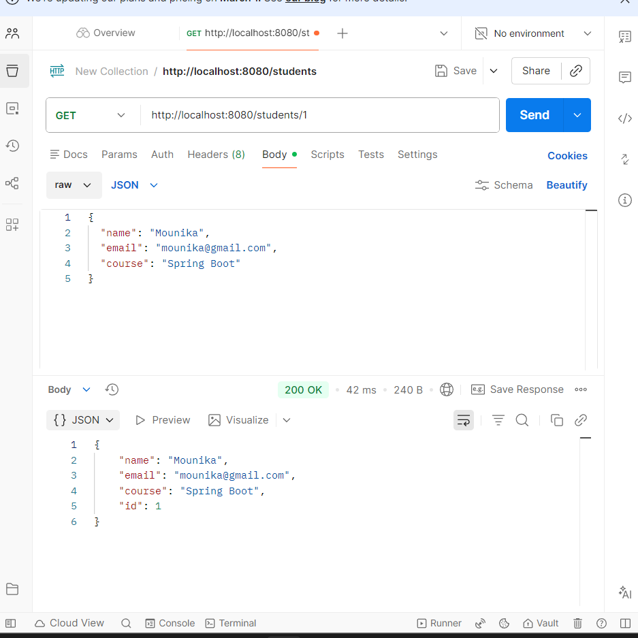
UPDATE Student
PUT
http://localhost:8080/students/1
{
"name": "Mounika R",
"email": "mounika123@gmail.com",
"course": "Java"
}
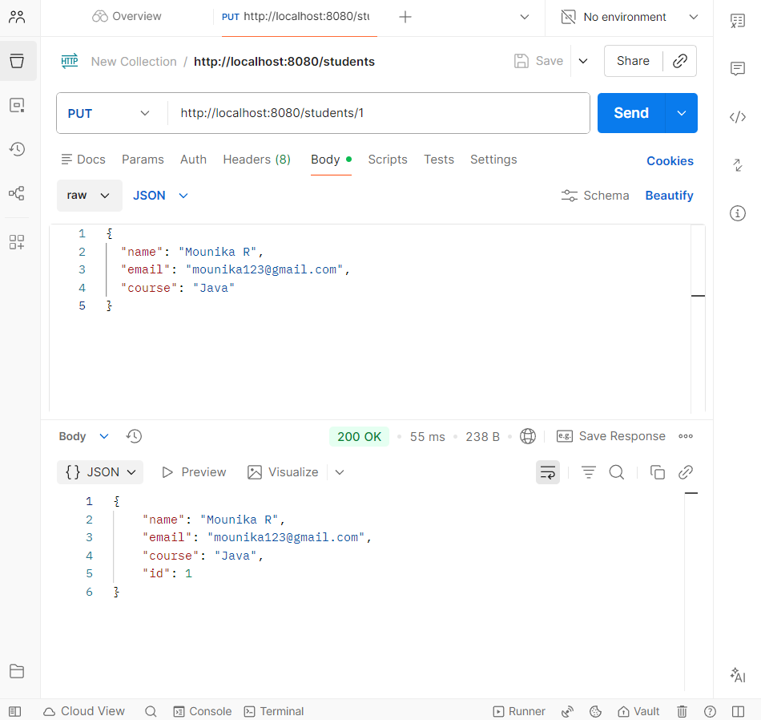
DELETE Student
DELETE
http://localhost:8080/students/1
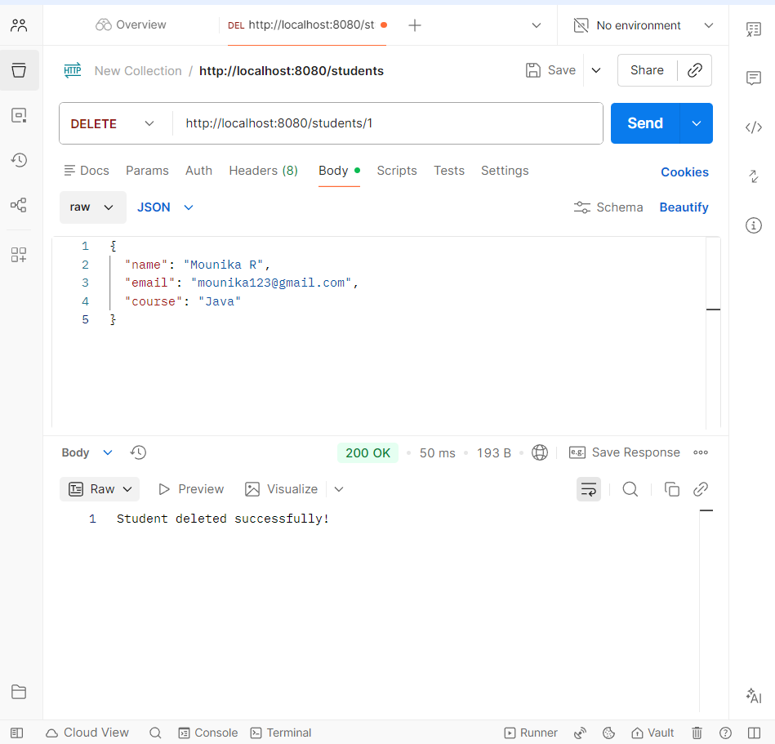
STEP 9: In mysql
